Performance Assessment 1 – QoS and IPv6

In this lab you will be using Packet Tracer.

Your network will a class B network based on a number assigned by your professor, which you will be using for the duration of the class. In the lab anytime you see an underline you should fill in this number.

**Student network: 10.____.0.0/16**

**Using the Packet Tracer create the network below**

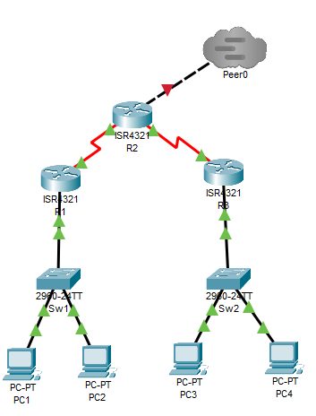

**Task 1 – Ipv6 and OSPFv3**

Program each of your routers and switches for the above network. Make sure you add serial modules (NIM-2T) to each router in the first slot available.

|  |  |  |  |
| --- | --- | --- | --- |
| **System** | **Port** | **Connect To** | **IP address** |
| R1 | G0/0/0 | Sw1 | 2001:DB8:___:1::1/64 |
|  | Se0/1/0 | R2 | FD00:0:___:9::1/64 |
| R2 | Se0/1/0 | R3 | FD00:0:___:10::1/64 |
|  | Se0/1/1 | R1 | FD00:0:___:9::2/64 |
| R3 | G0/0/0 | Sw2 | 2001:DB8:___:2::1/64 |
|  | Se0/1/1 | R2 | FD00:0:___:10::2/64 |

Program each router as shown above. An example is given to program R1. Make sure you bring the interfaces up.

R1(config)# ipv6 unicast-routing

R1(config)# interface g0/0/0

R1(config-if)# ipv6 enable

R1(config-if)# ipv6 address 2001:DB8:___:1::1/64

R1(config-if)# interface s0/1/0

R1(config-if)# ipv6 enable

R1(config-if)# ipv6 address FD00:0:___:9::1/64

Program each of the remaining routers. Pull and IPv6 address to each PC by clicking on the Auto Config button in the IPv6 configuration.

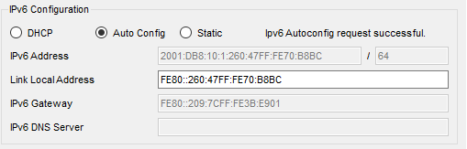

Setting up OSPFv3

Program into each router as follows

R1(config)# ipv6 router ospf 1

R1(config-rtr)# router-id 1.1.1.1

R1(config-rtr)# interface g0/0/0

R1(config-if)# ipv6 ospf 1 area 1

R1(config-if)# interface s0/1/0

R1(config-if)# ipv6 ospf 1 area 0

R2(config)# ipv6 router ospf 1

R2(config-rtr)# router-id 2.2.2.2

R2(config-rtr)# interface s0/1/0

R2(config-if)# ipv6 ospf 1 area 0

R2(config-if)# interface s0/1/1

R2(config-if)# ipv6 ospf 1 area 0

R3(config)# ipv6 router ospf 1

R3(config-rtr)# router-id 3.3.3.3

R3(config-rtr)# interface g0/0/0

R3(config-if)# ipv6 ospf 1 area 1

R3(config-if)# interface s0/1/1

R3(config-if)# ipv6 ospf 1 area 0

Verify that your OSPFv3 routing is working by using the command *show ipv6 route* on your R3 router to show the IPv6 routing table. Take a screenshot.

Go to your PC4 and copy your IPv6 address below. You can find it on your IPv6 configuration tab or by typing ipv6config in a command prompt window.

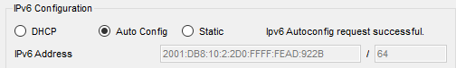

Go to your PC1 and type

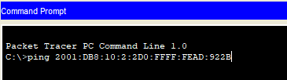

Take a screenshot of your successful IPv6 ping.

**Deliverables**

* Screenshot of your working network
* Screenshot of your IPv6 routing table from R3
* Screenshot of your successful IPv6 ping from PC1 to PC4

PASTE SCREENSHOTS BELOW

**Task 2 –Switch to IPv4**

|  |  |  |  |  |  |
| --- | --- | --- | --- | --- | --- |
| **System** | **Port** | **Connect To** | **IP address** | **Subnet Mask** | **Clock Rate** |
| R1 | G0/0/0.10 | Sw1 | 10.___.1.1 | 255.255.255.192 | 60 users |
|  | G0/0/0.20 | Sw1 | 10.___.1.65 | 255.255.255.224 | 30 users |
|  | Se0/1/0 | R2 | 10.___.5.1 | 255.255.255.252 | 500000 |
| R2 | G0/0/0 | Tier1 | 11.0.0.___ | 255.255.255.0 |  |
|  | Se0/1/0 | R3 | 10.___.5.5 | 255.255.255.252 | 500000 |
|  | SE0/1/1 | R1 | 10.___.5.2 | 255.255.255.252 |  |
| R3 | G0/1/0.10 | Sw2 | 10.___.2.1 | 255.255.255.224 | 28 Users |
|  | G0/1/0.20 | Sw2 | 10.___.2.33 | 255.255.255.240 | 12 Users |
|  | SE0/1/1 | R2 | 10.___.5.6 | 255.255.255.252 |  |

Program each of the routers and switches for IPv4 and add DHCP and OSPF routing to each router for your network.

1. You will create two DCHP pools on R1 and two on R3 for VLANs 10 and 20.
2. You will create and assign VLANs 10 and 20 on each switch for the PCs attached- don’t forget to configure the uplink on each switch as a trunk.
3. You will configure OSPF on each router- once all of this is configured you should be able to communicate between all the networks.

Ping from PC2 to PC3 using IPv4. Take a screenshot.

**Deliverables**

* Screenshot of a show run from R1 and R3 showing DCHP pools
* Screenshot of a show ip route form each router showing OSPF routes
* Screenshot of ping from PC2 to PC3

PASTE SCREENSHOTS BELOW

**Task 3 – Adding QoS**

QoS gives your routers rules to follow that it will apply to allow the most important packets to pass through while the least important are dropped. QoS rules only apply during times of congestion and the rest of the time they are ignored. That said, QoS is one of the most important parts of your network set-up and can cause users to have a much better experience from the network.

The first concept is very simple. During congestion we take different actions on different types of packets. To do this we mark each IP packet with a priority number called a differentiated services code point (DSCP) value. We do this by placing the number in the differentiated services (DS) field in the header. As an example, we have the following three packets marked with their priority number. The third packet (priority 1) would be dropped if there was not enough bandwidth to transmit the packet.

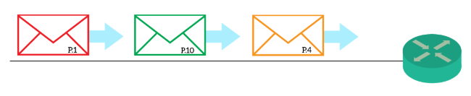

Packets are given three levels of priority: Best-effort, assured forwarding, and expedited forwarding.

Best-effort is the default behavior, and means no QoS. Routers will drop these packet as soon as a congestion happens: they forward them only if they have resources to do it.

Assured forwarding – This categorization defines that the network will assure delivery unless traffic exceeds a specific rate. The more the traffic exceeds that rate, the more the router will be inclined to drop it during congestions.

Finally, we have the expedited forwarding (EF). This is basically the best class: low delay, low jitter. We often see that for VoIP and Video, because it allows the fastest transfer.

Set up QoS for packets on R1

R1(config)#class-map match-any critical

R1(config-cmap)# match protocol icmp

R1(config-cmap)# match protocol http

R1(config-cmap)# match protocol https

R1(config)# policy-map Marked

R1(config-pmap)# class type inspect critical

R1(config-pmap-c)# set precedence 7

R1(config)# interface s0/1/0

R1(config-if)# service-policy output Marked

R1# show policy-map interface s0/1/0

Connect your network to the Tier1 network and ping from PC1 to your Tier1 server. Next run the command to show the policy-map for S0/1/0.

R1# show policy-map interface s0/1/0

Take a screenshot.

Place QoS onto each router interface connecting to another router.

R2: S0/1/0, S0/1/1, and G0/0/0

R3: S0/1/1

Verify that your QoS is working by pulling the policy-map for each interface. Take a screenshot of each interface.

**Deliverables for Task 3**

* Screenshot of policy-map for s0/1/0 for R1
* Screenshot of policy-map for each interface on R2
* Screenshot of policy-map for each interface on R3

PASTE SCREENSHOTS BELOW